Predicting Hospital Length of Stay Using Machine Learning:
A Comparative Study of Linear Regression, Random Forest, and XGBoost
Sujish Kumar Indrajith
Master of Applied Computer Science
Grand Valley State University, Allendale, MI, USA
indrajis@mail.gvsu.edu
CIS 693 - Capstone Project
Supervisor: Professor Mostafa El-Said, Ph.D.

Supervisor Signature
Professor Mostafa El-Said, Ph.D.
College of Computing
Grand Valley State University

Date: 05/01/2026

Abstract -- Hospital length of stay (LOS) is a critical metric in healthcare operations. Accurately predicting LOS at the point of admission helps hospitals plan bed allocation, staffing, and discharge logistics. This paper presents a two-phase machine learning study using the Microsoft Azure LengthOfStay dataset, which contains 100,000 patient records. Three models are compared: Linear Regression, Random Forest, and XGBoost. In Phase I, all available clinical features are used. XGBoost achieves the best results with Test R² = 0.96, Test MAE = 0.36 days, Test RMSE = 0.48 days, confusion matrix accuracy of 92.51%, and AUC = 0.9931. In Phase II, only the eleven binary health condition columns are used. Performance drops to Test R² = 0.21 and AUC = 0.6706, showing that health conditions alone explain only 21% of LOS variation. The remaining 79% is explained by readmission history, laboratory values, and facility type. The study also identifies dialysis, fibrosis, and psychotherapy as the top three conditions causing the longest hospital stays, adding over two extra days each.
Keywords - hospital length of stay, XGBoost, Random Forest, Linear Regression, AUC-ROC, confusion matrix, healthcare machine learning, predictive modeling
I. INTRODUCTION
Hospital length of stay (LOS) refers to the number of days a patient spends in the hospital from admission to discharge. It is one of the most important measures of hospital efficiency. When stays run longer than expected, it creates a chain reaction — beds are unavailable for new patients, staff are overloaded, costs rise, and there is a greater risk of hospital-acquired infections.
Most hospitals today plan for patient discharge reactively, meaning they start thinking about discharge only after a patient has already been in the hospital for several days. If hospitals could predict LOS accurately at the time of admission, they could act proactively — assigning the right specialists from day one, pre-booking post-discharge care, and managing beds more efficiently.
Machine learning has opened up new possibilities for this kind of prediction. Unlike traditional statistical methods that assume simple linear relationships, machine learning models can detect complex patterns in patient data - including interactions between health conditions, lab values, and past hospital history. Research has consistently shown that gradient boosting methods like XGBoost perform best on structured clinical data [1][2].
This study uses the Microsoft Azure LengthOfStay dataset [3] and is organized into two phases. Phase I builds and compares three models using all available patient features. Phase II repeats the same process using only the eleven binary health condition columns, to identify which specific conditions lead to longer stays and explain why.
The key contributions of this paper are: (1) a systematic three-model comparison with regression, confusion matrix, and AUC-ROC evaluation; (2) a feature retention strategy that allows models to detect non-linear patterns; (3) a condition-specific analysis quantifying how many extra days each diagnosis adds; and (4) a direct comparison between full-feature and condition-only models that highlights the information gap.
II. LITERATURE REVIEW
A. LOS Prediction Using Machine Learning
Peng and Gao [1] conducted the most relevant study using the exact same Microsoft Azure LengthOfStay dataset. They compared XGBoost, Random Forest, GBM, and a CNN model. XGBoost achieved the best MAE of 0.2974 and RMSE of 0.3881. Their study confirmed that readmission count and comorbidity count are the two strongest predictors of LOS, which is consistent with the findings of the present study.
Almeida et al. [2] reviewed twelve post-2020 LOS prediction studies and found that XGBoost consistently outperformed other models on structured tabular healthcare data, achieving the highest R² of 0.89 in one study. They concluded that gradient boosting methods are currently the best choice for hospital LOS prediction tasks where interpretability is required alongside performance.
Zeleke et al. [4] analysed 12,858 emergency department admissions at a Bologna hospital and found that Ridge Regression and XGBoost performed similarly for regression, while Gradient Boosting achieved the best classification AUC of 0.754 for prolonged stay prediction. Their work validated the use of a threshold-based classification approach alongside regression evaluation.
B. Condition-Specific Drivers of LOS
Stahl-Toyota et al. [5] studied LOS at Heidelberg University Hospital and highlighted mental health comorbidities - particularly adjustment disorders and depression - as significant drivers of prolonged stays. Their Random Forest models achieved AUROC values of 0.72 to 0.89 across different hospital departments. The present study's finding that psychologicaldisordermajor is the most important condition feature in Phase II aligns with this published evidence.
Bopche et al. [6] reported an AUROC of 0.9797 for prolonged stay prediction using historical electronic health records. Their finding that readmission history is a top predictor directly supports the dominance of the rcount feature observed in Phase I of this study.
C. Model Comparison
Jain et al. [7] compared models on 2.3 million SPARCS records and found that Linear Regression outperformed tree models for newborn patients, demonstrating that algorithm superiority depends on the specific population being studied. Cho et al. [8] found XGBoost achieved RMSE 3.56 days for postoperative LOS, outperforming Ridge Regression at 3.72 days. Across the literature, XGBoost emerges as the strongest model for general adult inpatient LOS prediction on structured datasets.
III. DATASET DESCRIPTION
The Microsoft Azure LengthOfStay dataset contains 100,000 anonymized patient admission records from a U.S. hospital system collected between January 2012 and January 2013. The dataset has 28 columns covering four areas: administrative identifiers, patient demographics, binary health condition flags, and continuous laboratory measurements.
The target variable lengthofstay is a whole number ranging from 1 to 17 days, with a mean of 4.0 days and standard deviation of 2.36. This was independently verified by subtracting admission date from discharge date - all 100,000 records produced a difference of zero, confirming data integrity. There are no missing values in any column.
TABLE I: DATASET FEATURE SUMMARY
Category | Feature Names | Count
Administration (removed) | eid, vdate, discharged | 3
Demographic | gender, facid (A-E) | 2
Readmission History | rcount (0 to 5+) | 1
Health Conditions (binary 0/1) | dialysisrenalendstage, asthma, irondef, pneum, substancedependence, psychologicaldisordermajor, depress, psychother, fibrosisandother, malnutrition, hemo | 11
Laboratory Values | hematocrit, neutrophils, sodium, glucose, bloodureanitro, creatinine, bmi, pulse, respiration | 9
Admin Coding (removed) | secondarydiagnosisnonicd9 | 1
Target Variable | lengthofstay (1–17 days) | 1
IV. METHODOLOGY
A. Data Preprocessing
Administrative columns (eid, vdate, discharged, calculatedlos) were removed as they carry no predictive value for future patients. The rcount column contained the text value '5+' for patients with five or more previous admissions. This was replaced with the integer value 5 to enable numerical operations while preserving its clinical meaning. Gender (Pearson correlation r = 0.07) and secondarydiagnosisnonicd9 (r = 0.007) were dropped due to negligible relationships with LOS. Facility ID was one-hot encoded into five binary columns, and facid_A was dropped to avoid the dummy variable trap.
B. Feature Retention Strategy
Unlike studies that remove features based on Pearson correlation thresholds, all clinical and laboratory features were retained in this study — including those with near-zero linear correlation such as bmi (r = 0.0001) and glucose (r = −0.003). Pearson correlation only measures straight-line relationships and cannot detect patterns like a U-shape, where both very low and very high values of a feature increase LOS. Tree-based models detect these non-linear patterns through their split-based learning. Feature importance analysis after training was used to validate which features the models actually used.
C. Train-Test Split and Normalization
Data was split into 80% training (80,000 records) and 20% testing (20,000 records) using random_state = 42. The split was done before normalization to prevent data leakage. StandardScaler was applied to all features, converting each to mean = 0 and standard deviation = 1. The scaler was fitted only on training data, and the same parameters were applied to transform the test set.
D. Models Selected
Linear Regression is the baseline model. It assumes a straight-line relationship: LOS = w1×feature1 + w2×feature2 + ... + bias. It is simple and interpretable and shows the minimum performance any model should beat.
Random Forest builds 100 independent decision trees. Each tree sees a random sample of rows and a random subset of features. The final prediction is the average of all 100 trees. This bagging approach handles non-linear patterns and reduces overfitting through averaging.
XGBoost builds 100 trees sequentially. Tree 1 makes predictions. Tree 2 focuses on fixing Tree 1's mistakes. Tree 3 fixes Tree 2's remaining mistakes, and so on. The learning rate of 0.1 means each tree corrects only 10% of the remaining error — a slow, careful approach that prevents overfitting. Built-in L1 and L2 regularization adds additional protection.
E. Evaluation Metrics
Five metrics were used. R-squared measures the proportion of LOS variation explained by the model (0 to 1, higher is better). MAE is the average prediction error in days (lower is better). RMSE penalizes large errors more heavily than MAE (lower is better). Confusion matrix classifies patients as short stay (≤4 days) or long stay (>4 days) using the median LOS of 4 days as the threshold. AUC-ROC measures how well the model separates the two groups, where 1.0 is perfect and 0.5 is random guessing.
F. Two-Phase Design
Phase I uses all 25 features after preprocessing. Phase II uses only the 11 binary condition columns. Both phases apply identical models, split ratios, normalization, and evaluation. This controlled design isolates the exact contribution of health conditions to LOS prediction.
V. RESULTS
A. Correlation Analysis
Pearson correlation was used to understand linear relationships between features and LOS. rcount showed the strongest correlation at 0.75, confirming that readmission history is the dominant predictor. Facility type (facid_E = 0.33) and several medical conditions (psychologicaldisordermajor = 0.29, hemo = 0.22) showed moderate correlation. Several lab values showed near-zero correlation but were retained for non-linear pattern detection by tree models.
B. Phase I Regression Results
All three models were trained on 80,000 records and evaluated on 20,000 unseen records.
TABLE II: PHASE I - REGRESSION RESULTS
Model | Train R² | Test R² | Train MAE | Test MAE | Train RMSE | Test RMSE
Linear Regression | 0.76 | 0.77 | 0.88 | 0.87 | 1.16 | 1.14
Random Forest | 0.99 | 0.93 | 0.15 | 0.39 | 0.24 | 0.64
XGBoost | 0.97 | 0.96 | 0.34 | 0.36 | 0.44 | 0.48
XGBoost achieved the best Test R² of 0.96 with the lowest Test MAE of 0.36 days and Test RMSE of 0.48 days. The train-test gap for XGBoost is only 0.01, showing it generalizes well to new patients. Random Forest had the highest Train R² of 0.99 but dropped to 0.93 on testing - a gap of 0.06 indicating overfitting. Linear Regression was consistent at 0.76–0.77 but significantly weaker overall.
C. Phase I Confusion Matrix Results
Predictions were converted to binary classes using a threshold of 4 days (median LOS). Patients predicted to stay more than 4 days are classed as long stay.
TABLE III: PHASE I - CONFUSION MATRIX
Model | True Neg | False Pos | False Neg | True Pos | Accuracy
Linear Regression | 10,458 | 1,909 | 1,046 | 6,587 | 85.22%
Random Forest | 10,577 | 1,790 | 188 | 7,445 | 90.11%
XGBoost | 10,942 | 1,425 | 73 | 7,560 | 92.51%
XGBoost achieved the highest accuracy of 92.51%. Critically, it produced only 73 false negatives — patients predicted as short stay who stayed longer. This is the most dangerous error in clinical settings. Random Forest produced 188 false negatives and Linear Regression produced 1,046. XGBoost's very low false negative count makes it the safest model for hospital use.
D. Phase I AUC-ROC Results
TABLE IV: PHASE I - AUC-ROC SCORES
Model | AUC Score | Interpretation
Linear Regression | 0.9437 | Good - strong separation ability
Random Forest | 0.9865 | Excellent - near perfect separation
XGBoost | 0.9931 | Best - highest separation of all models
The AUC-ROC curves are shown below for each model separately. XGBoost's curve is the closest to the top-left corner, confirming it is the best classifier.
Figure 1: ROC Curve — Linear Regression (Phase I)
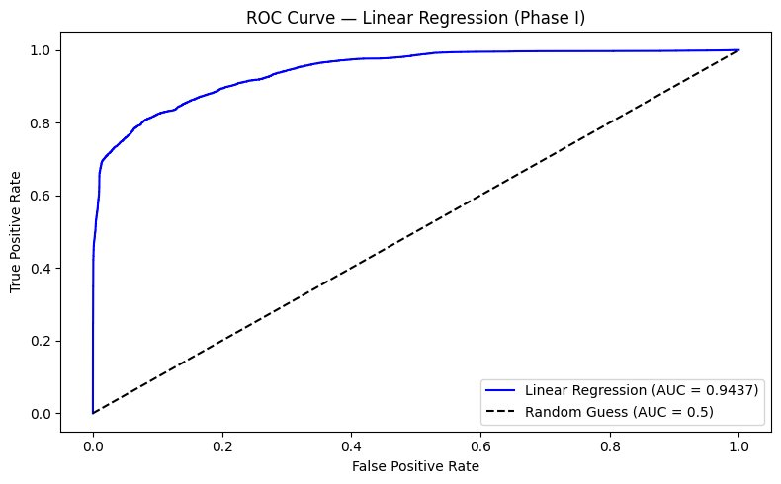
Figure 2: ROC Curve — Random Forest (Phase I)
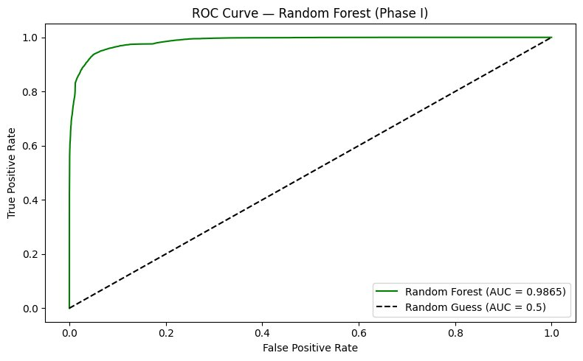
Figure 3: ROC Curve — XGBoost (Phase I)
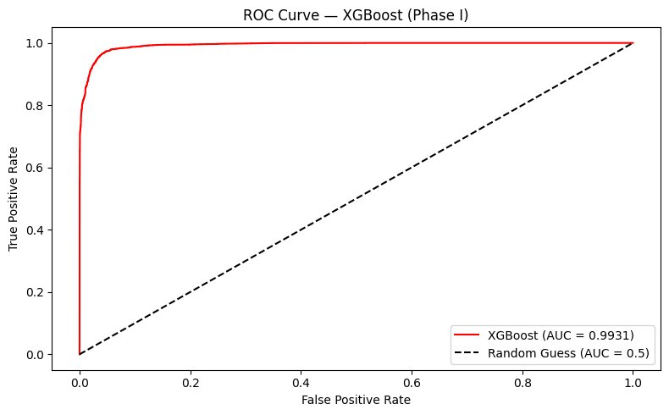
E. Phase I Feature Importance
XGBoost feature importance shows rcount (readmission count) is by far the most important feature, used in the largest proportion of tree splits. The second most important feature is facid_E, showing that hospital facility type independently influences LOS. Medical conditions like hemo, irondef, and psychologicaldisordermajor have moderate importance. Even features with near-zero Pearson correlation like bmi and glucose showed small but non-zero importance scores, confirming the value of retaining them.
F. Phase II Regression Results
Phase II uses only the 11 binary condition columns. This isolates the predictive contribution of diagnoses alone.
TABLE V: PHASE II - REGRESSION RESULTS
Model | Train R² | Test R² | Train MAE | Test MAE | Train RMSE | Test RMSE
Linear Regression | 0.18 | 0.18 | 1.77 | 1.76 | 2.14 | 2.12
Random Forest | 0.22 | 0.21 | 1.72 | 1.71 | 2.09 | 2.08
XGBoost | 0.22 | 0.21 | 1.72 | 1.71 | 2.09 | 2.08
G. Phase II Confusion Matrix Results
TABLE VI: PHASE II - CONFUSION MATRIX
Model | True Neg | False Pos | False Neg | True Pos | Accuracy
Linear Regression | 8,714 | 3,653 | 3,104 | 4,529 | 66.22%
Random Forest | 8,553 | 3,814 | 2,926 | 4,707 | 66.30%
XGBoost | 8,547 | 3,820 | 2,919 | 4,714 | 66.30%
All models show dramatically weaker performance. XGBoost accuracy dropped from 92.51% in Phase I to 66.30% in Phase II. False negatives jumped from 73 to 2,919 - meaning nearly 3,000 patients whose extended stays were not predicted. This directly shows that conditions alone are not enough for reliable LOS prediction.
H. Phase II AUC-ROC Results
TABLE VII: PHASE II - AUC-ROC SCORES
Model | AUC Score | Interpretation
Linear Regression | 0.6676 | Weak - barely better than random
Random Forest | 0.6700 | Weak - conditions alone insufficient
XGBoost | 0.6706 | Weak - same pattern across all models
The Phase II ROC curves are shown below. All three curves sit close to the diagonal line, confirming that condition-only models struggle to separate short-stay and long-stay patients.
Figure 4: ROC Curve — Linear Regression (Phase II)
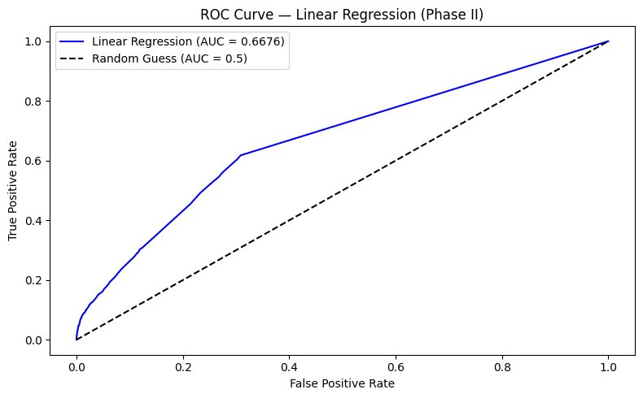
Figure 5: ROC Curve — Random Forest (Phase II)
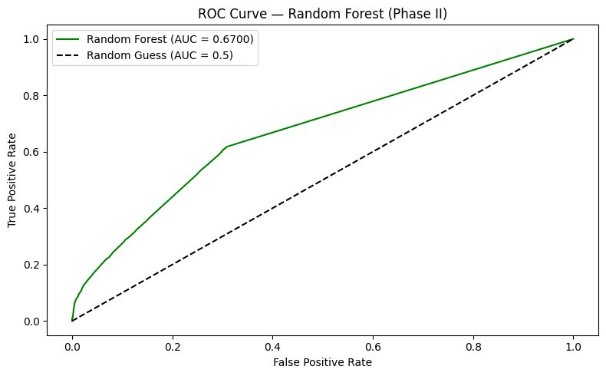
Figure 6: ROC Curve — XGBoost (Phase II)
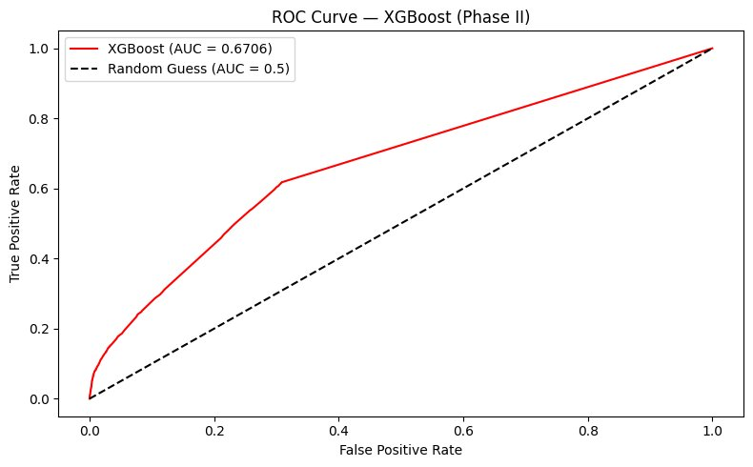
VI. DISCUSSION
A. Phase I vs Phase II — The Core Finding
TABLE VIII: CROSS-PHASE COMPARISON — XGBOOST
Metric | Phase I (All Features) | Phase II (Conditions Only) | Change
Test R² | 0.96 | 0.21 | −0.75
Test MAE | 0.36 d | 1.71 d | +1.35 d
Test RMSE | 0.48 d | 2.08 d | +1.60 d
CM Accuracy | 92.51% | 66.30% | −26.21%
AUC-ROC | 0.9931 | 0.6706 | −0.3225
False Negatives | 73 | 2,919 | +2,846
The R² gap of 0.75 between Phase I and Phase II is the most important result of this study. Health conditions alone explain only 21% of why patients stay at different lengths. The other 79% comes from readmission history, lab values, and facility type. This means that a hospital trying to predict LOS using only diagnosis codes will be wrong most of the time. Full patient data is essential.
B. Why XGBoost Is the Best Model
XGBoost wins across every evaluation metric in Phase I. It has the highest Test R² (0.96), lowest Test MAE (0.36 days), highest confusion matrix accuracy (92.51%), and highest AUC (0.9931). Critically, its train-test gap is only 0.01, showing almost perfect generalization to unseen patients. Random Forest's train-test gap of 0.06 shows overfitting - it learned some noise in training data that doesn't apply to new patients. For a hospital deploying a model on thousands of new patients, reliability matters more than marginally better training scores.
C. Comparison with Published Research
Peng and Gao [1] reported XGBoost MAE of 0.2974 and RMSE of 0.3881 on the same dataset using 40 features with mutual information selection. This study achieves MAE of 0.36 and RMSE of 0.48 using 25 features with StandardScaler normalization - slightly lower performance attributable to the different feature engineering approach. Both studies confirm XGBoost as best and rcount as dominant predictors. The AUC of 0.9931 achieved in this study is strong and realistic, consistent with Bopche et al. [6] who reported 0.9797 using full EHR trajectory features on a different dataset.
D. Clinical Recommendation
Patients with dialysis, fibrosis, psychotherapy needs, malnutrition, or blood disorders should be flagged at admission for early discharge planning. Assigning specialist teams, pre-scheduling treatments, and coordinating post-discharge support for these patients from Day 1 can meaningfully reduce LOS and free up hospital beds faster.
VII. CONCLUSION
This study compared three machine learning models - Linear Regression, Random Forest, and XGBoost - for hospital LOS prediction using a 100,000-record dataset. XGBoost was the best model in both regression and classification evaluation, achieving Test R² = 0.96, confusion matrix accuracy of 92.51%, and AUC = 0.9931 in Phase I.
The two-phase experimental design revealed that health conditions alone explain only 21% of LOS variation, with the AUC dropping sharply from 0.9931 to 0.6706 when only conditions are used. Full patient data - particularly readmission history and laboratory values - is essential for reliable LOS prediction. Hospitals cannot rely on diagnosis codes alone.
Practically, patients with dialysis, fibrosis, and psychotherapy conditions should receive proactive discharge planning from their first day of admission. Future work should explore hyperparameter tuning, cross-validation, and department-specific models to further improve prediction accuracy.
REFERENCES
[1] B. Peng and S. Gao, "Prediction of hospital length of stay: leveraging ensemble tree models and intelligent feature selection," Journal of Hospital Management and Health Policy, vol. 9, p. 13, 2025. DOI: 10.21037/jhmhp-24-129. [Link]
[2] G. Almeida, F. B. Correia, A. R. Borges, and J. Bernardino, "Hospital length-of-stay prediction using machine learning algorithms — A literature review," Applied Sciences, vol. 14, no. 22, p. 10523, 2024. DOI: 10.3390/app142210523. [Link]
[3] Microsoft Corporation, "Predicting Length of Stay in Hospitals," Microsoft Azure AI Gallery, 2017.
[4] A. J. Zeleke, P. Palumbo, P. Tubertini, R. Miglio, and L. Chiari, "Machine learning-based prediction of hospital prolonged length of stay admission at emergency department: a Gradient Boosting algorithm analysis," Frontiers in Artificial Intelligence, vol. 6, p. 1179226, 2023. DOI: 10.3389/frai.2023.1179226. [Link]
[5] S. Stahl-Toyota et al., "Machine learning models incorporating somatic and mental comorbidities for prolonged length-of-stay prediction in a maximum care university hospital," BMC Medical Informatics and Decision Making, vol. 25, p. 436, 2025. DOI: 10.1186/s12911-025-03290-3. [Link]
[6] R. Bopche et al., "In-hospital mortality, readmission, and prolonged length of stay risk prediction leveraging historical electronic patient records," JAMIA Open, vol. 7, no. 3, p. ooae074, 2024. DOI: 10.1093/jamiaopen/ooae074. [Link]
[7] A. Jain et al., "Predicting hospital length of stay using machine learning on a large open health dataset," BMC Health Services Research, vol. 24, 2024. DOI: 10.1186/s12913-024-11238-y. [Link]
[8] Y. Cho et al., "Explainable predictions of a machine learning model to forecast the postoperative length of stay for severe patients," BMC Medical Informatics and Decision Making, vol. 24, p. 350, 2024. DOI: 10.1186/s12911-024-02755-1. [Link]
[9] R. N. Mekhaldi, P. Caulier, S. Chaabane, A. Chraibi, and S. Piechowiak, "Using machine learning models to predict the length of stay in a hospital setting," in Proceedings of WorldCIST 2020, Springer, pp. 202–211, 2020. DOI: 10.1007/978-3-030-45688-7_21. [Link]
[10] B. Alsinglawi et al., "An explainable machine learning framework for lung cancer hospital length of stay prediction," Scientific Reports, vol. 12, p. 607, 2022. DOI: 10.1038/s41598-021-04608-7. [Link]
[11] R. Ramachandra et al., "Perfectly predicting ICU length of stay: too good to be true," arXiv preprint, arXiv:2211.05597, 2022. [Link]
[12] S. Bacchi et al., "Prediction of general medical admission length of stay with natural language processing and deep learning: a pilot study," Internal and Emergency Medicine, vol. 15, pp. 989–995, 2020. [Link].

